Name: Maloth Aditya

Roll No.: 120CS0124

**Exercise 1:**

**Code:**

animal(lion).

animal(tiger).

animal(cow).

carnivore(lion).

carnivore(tiger).

check_carnivore(X):- animal(X),carnivore(X).

**Output:**

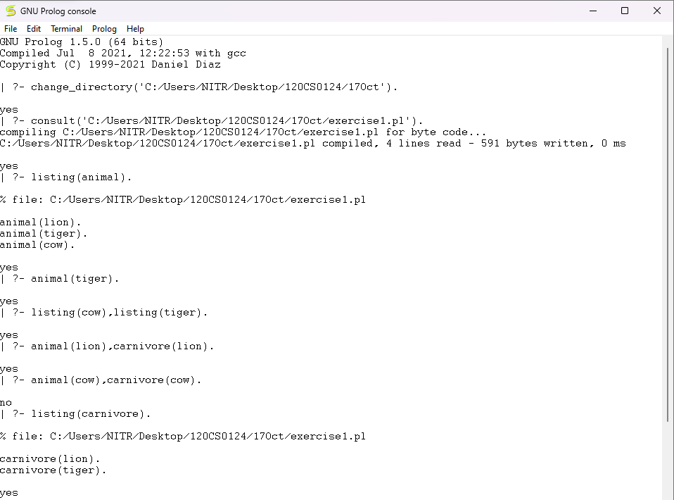

**Exercise 2:**

**Code:**

animal(mammal,tiger,carnivore,stripes).

animal(mammal,hyena,carnivore,ugly).

animal(mammal,lion,carnivore,mane).

animal(mammal,zebra,herbivore,stripes).

animal(bird,eagle,carnivore,large).

animal(bird,sparrow,scavenger,small).

animal(reptile,snake,carnivore,long).

animal(reptile,lizard,scavenger,small).

mammal(W):-animal(mammal,X,Y,Z).

carnivore(W):-animal(X,Y,carnivore,Z).

**Output:**

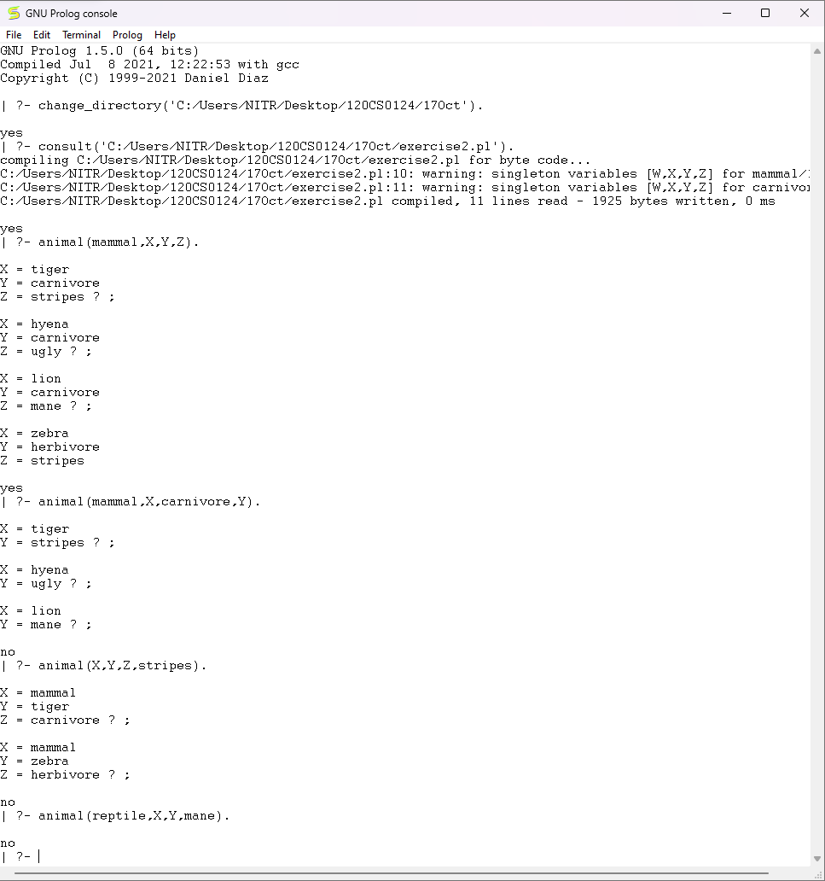

**Exercise 3:**

**Code:**

american(west).

country(nono).

missile(m1).

hostile(nono).

criminal(X) :- american(X), sells_weapons_to_hostile(Y), country(Y), hostile(Y).

sells_weapons_to_hostile(Y) :- american(X), missile(Z), country(Y), hostile(Y), sells(X,Z,Y).

sells(west,m1,nono).

**Output:**

